2.4 Flame Sensor Module

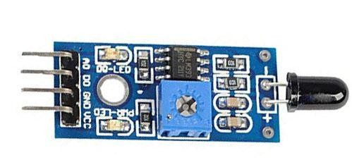A flame detector is a [sensor](https://en.wikipedia.org/wiki/Sensor) designed to detect and respond to the presence of a [flame](https://en.wikipedia.org/wiki/Flame) or [fire](https://en.wikipedia.org/wiki/Fire), allowing flame detection. Responses to a detected flame depend on the installation, but can include sounding an alarm, deactivating a fuel line (such as a [propane](https://en.wikipedia.org/wiki/Propane) or a [natural gas](https://en.wikipedia.org/wiki/Natural_gas) line), and activating a fire suppression system. When used in applications such as industrial furnaces, their role is to provide confirmation that the furnace is working properly; it can be used to turn off the ignition system though in many cases they take no direct action beyond notifying the operator or control system. A flame detector can often respond faster and more accurately than a [smoke](https://en.wikipedia.org/wiki/Smoke_detector) or [heat detector](https://en.wikipedia.org/wiki/Heat_detector) due to the mechanisms it uses to detect the flame.

**Figure 2.4 flame sensor**

### 2.4.1 Working Principle

This sensor/detector can be built with an [electronic circuit](https://www.elprocus.com/top-10-simple-electronic-circuits-for-beginners/) using a receiver like electromagnetic radiation. This sensor uses the infrared flame flash method, which allows the sensor to work through a coating of oil, dust, water vapor, otherwise ice.

# 2.4.2 Interface Description (4-wire)

1. VCC -- 3.3V-5V voltage
2. GND -- GND
3. DO -- board digital output interface (0 and 1)
4. AO -- board analog output interface

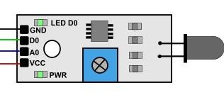

**Figure 2.4.2 flame sensor interface**

### 2.4.3Features & Specifications

* Detection angle is 600
* It is responsive to the flame range.
* Accuracy can be adjustable
* Operating voltage of this sensor is 3.3V to 5V
* Analog voltage o/ps and digital switch o/ps
* The PCB size is 3cm X 1.6cm
* Power indicator & digital switch o/p indicator
* If the flame intensity is lighter within 0.8m then the flame test can be activated, if the flame intensity is high, then the detection of distance will be improved.

#include <Arduino.h>

#include <ESP8266WiFi.h>

#include <ESP8266WiFiMulti.h>

#include <ESP8266HTTPClient.h>

#include <WiFiClient.h>

// Have fun ?

/*

2. * PIR sensor tester

3. */

#define ledPin D0

#define inputPin D1

/*int ledPin = 13; // choose the pin for the LED

int inputPin = 2; // choose the input pin (for PIR sensor)*/

int pirState = LOW; // we start, assuming no motion detected

void setup(){

Serial.begin(115200);

pinMode(ledPin, OUTPUT); // declare LED as output

pinMode(inputPin, INPUT); // declare sensor as input

}

void loop(){

int val = 0; // variable for reading the pin status

val = digitalRead(inputPin); // read input value

if (val == 0) { // check if the input is HIGH

Serial.println("Fire\n");

digitalWrite(ledPin, HIGH); // turn LED ON

delay(1000);

} else {

Serial.println("NormalState");

digitalWrite(ledPin, HIGH);

delay(250);

digitalWrite(ledPin, LOW);

}

}